Supporting materials for Quality in Care Diabetes 2020.
Title of entry:
Developing a community ‘Walk in’ Clinic for diabetic foot disease. (10 words MAXIMUM)

- Supporting materials – 1. Flier advertising ‘Walk in’ clinic (WIC) displayed on TV screens within GP surgeries and printed as a poster.
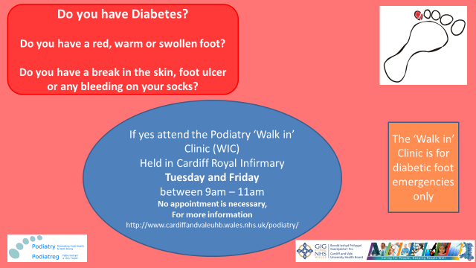
- Supporting materials – 2. WIC information shared through social media by GP practices.

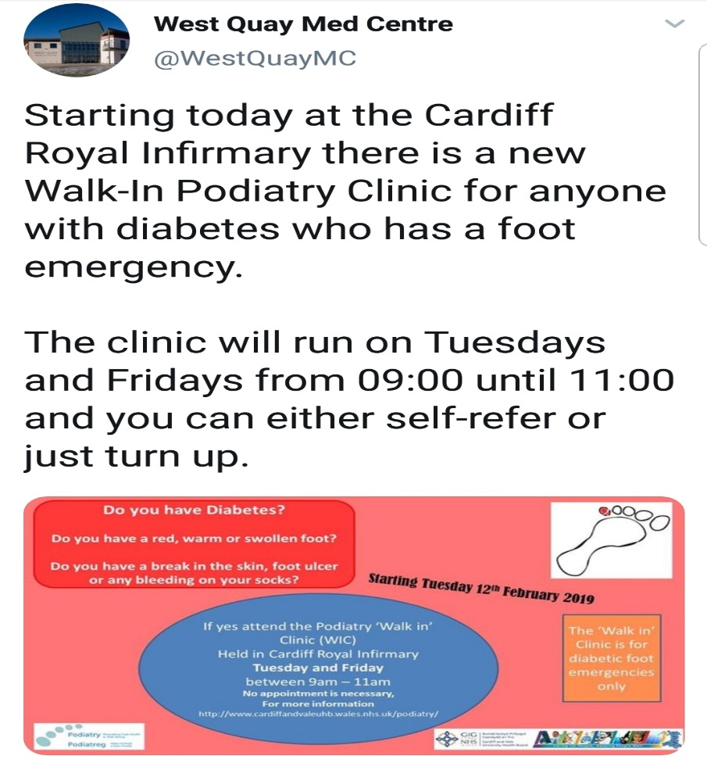

- Supporting materials – 3. All Wales Patient Infographic. Healthy me: My healthy feet.
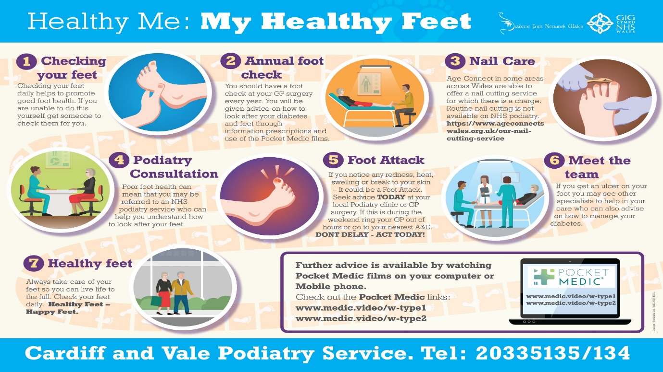

- Supporting materials – 4. All Wales DFU pathway.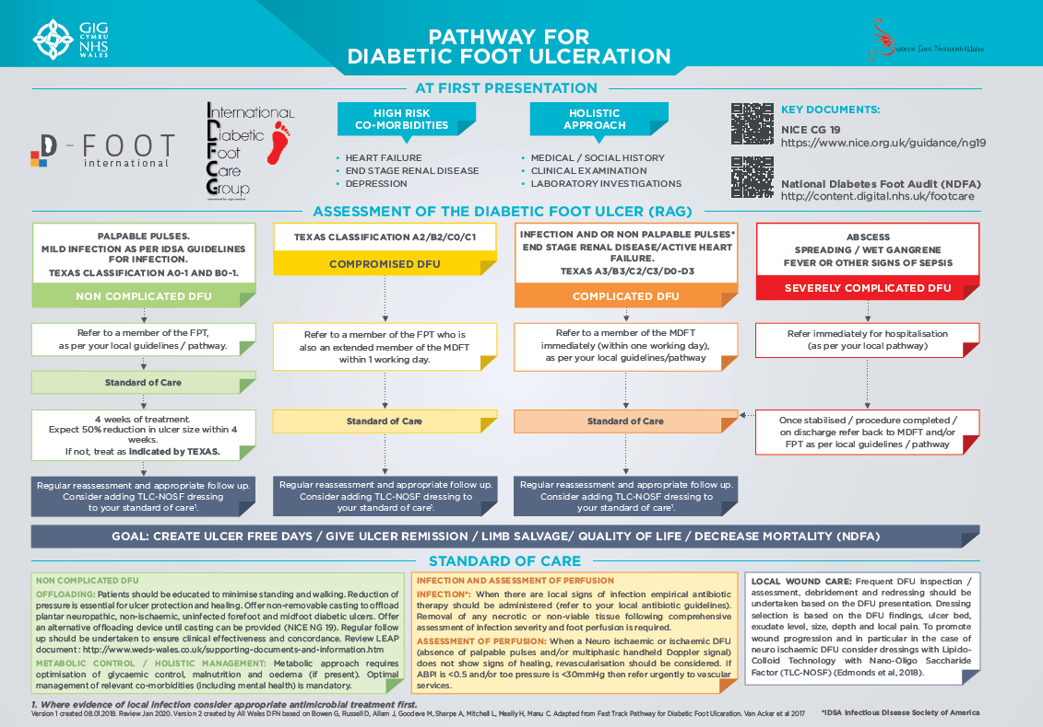

- Supporting materials – 5. Cardiff and Vale Diabetic ‘Walk in’ clinic update, June 2020.
