Diabetes schools educator nurse – interim report - October 2016

Background
Dr Justin Warner was appointed as a Diabetes UK clinical champion in 2015 and he chose ‘schools’ as his focus as it is well known within diabetes clinics that diabetes management in schools varies considerably and that poor understanding of diabetes by school staff often results in pupils not accessing the support they need to manage their condition effectively. This affects both their health and their educational attainment.
Dr Warner was very keen to appoint a ‘school educator’, whose primary focus would be to provide support, education and guidance to school staff on the safe management of diabetes in schools.
Dr Sharon Hopkins, quality improvement manager, agreed to support a 22.5hr Band 7 role until the end of the 2016-2017 financial year. In February 2016 Corinna Bretland was appointed to this role. Owing to in house staff shortages at that time, as well as school holidays at the end of March, the role commenced fully at the start of April 2016.
What have I been doing?
Current caseload information suggests that the Cardiff and Vale Paediatric diabetes service supports 165 schools across a 181mile² area.
120 Cardiff schools (50 primary / 70 secondary)
45 Vale schools (20 primary / 25 secondary)
70 children accessing nursery – yr6
120 children accessing yr7 – yr13

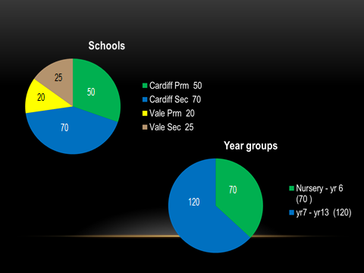

During 5 months (April, May, June, July and September) I made contact with more than 600 school staff and undertook more than 100 school visits. At this visits I provided training and advice to staff, education to children and support for parents who had concerns about diabetes management at their child’s school.
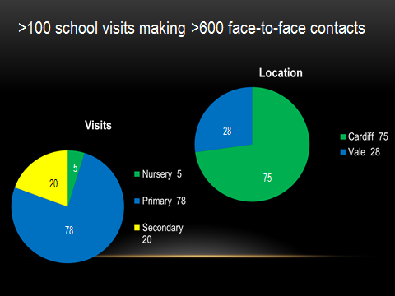
Presentations:
I have been invited to speak at a number of meetings to raise awareness of my role. Meetings I have presented at include:
- Three consecutive days of meetings for head teachers and SENCOs from Cardiff primary and Cardiff secondary schools
- A head teacher meeting for Vale secondary and primary schools
- Vale ‘healthy schools’ meeting – a gathering of secondary school staff leading on PSE in their school
- Brecon group meeting – the annual meeting for diabetes healthcare professionals working across Wales

Qualifications:
I successfully passed my PgCEd in May 2016 with a distinction from USW.

Gathering Feedback:
Using ‘Survey Monkey’, I surveyed school staff and parents to get feedback regarding the support and education they had received. The survey results were very positive. Comments include:
- The service we have received has been and continues to be incredible and we are very lucky to have such great support

- Excellent training, very informative and helped to ease my concerns. I now feel capable to support our pupil with his diabetes needs. Thanks

- I was apprehensive about her going on a residential trip but following the meeting I was rest assured everything was in place.

- Fantastic education provided to date. Thank you so much for providing this incredibly important service.

- Fantastic service! Made me feel fully supported with my issues at the school and made the school take notice.

- Very worthwhile and informative

- Absolutely second to none. The service is provided without reservation and as a matter of urgency. The service is valued by me and my family. I hope it's here to stay.

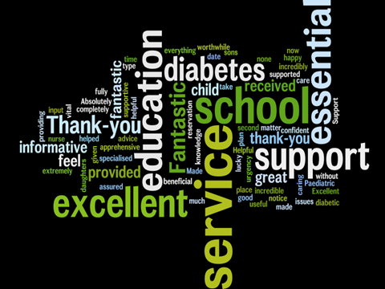

I also sought feedback from the rest of the diabetes team regarding the implementation of the new role. Overall the team are very supportive of the new role and they feel that it provides a positive addition to the service we offer our patients and their families. Some of their comments include:
- It has freed up time for the other PDSNs to continue with other clinical work
- Feedback from parents and children is that school communication is much improved and it is useful to have a point of contact within the team
- Able to provide more proactive care and education, It has also allowed more time for service development and CPD.
- I do feel that we have lost a personal link with the schools and that ability to provide holistic care for our patients for whom we are the named nurse.
- The role positively supports a developing diabetes team. Point of contact for the schools and ability to provide ongoing support as and when is needed
- This role helps the team to be more resourceful and proactive in their roles

What’s next?
- Secure ongoing funding – Risk Assessment procedure underway
- Bench-marking with other diabetes units both in wales and England. Some centres provide diabetes training sessions that schools are invited to attend. This results in update training being provided to many schools simultaneously as well as getting schools together to share best practice
- Write a job description
- Develop more pro-active ways of working eg. prepare for transition to high school in line with the schools’ transition programme
- Closer liaison with school nurses

