

Northern Clinical Networks and Senate

Case study: Blood in Pee –
washroom campaign
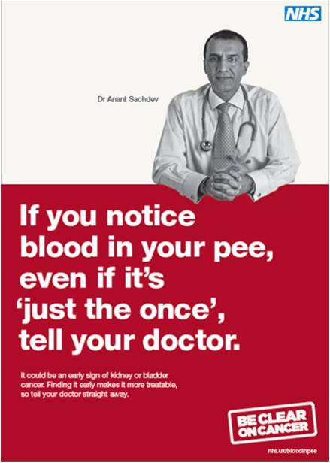
Background

In itself the relationship the Cancer Network has built up with local employers has been a great success. Be Clear on Cancer had been embraced by a vast array of local organisations and businesses through a range of channels including the 'Better Health at Work' initiative across the North East (managed by Northumbria NHS healthcare trust) and the local branch of the TUC in Cumbria who opened up its network of Learning Reps to us to support health promotion through its members.

Our workplace partners had supported us well during both the national lung and bowel cancers campaigns, with a good distribution of literature across over hundreds of organisations to thousands of their staff. However, we knew information in most cases was not displayed or distributed in a co-ordinated way once it arrived in an organisation and promotional support ranged from planned, special awareness presentations to staff to a stack of leaflets put in the canteen and a poster on a notice board.

But, for Blood in Pee, we wanted to do something more targeted this time. So we devised the 'washroom campaign'.

Everyone uses the loo!
At some stage during the work-day just about everyone uses the loo so it seemed to be the obvious place to promote the Blood in Pee message.

Because a supply of posters was free from the national team, we approached our workplace contacts with the concept of the washroom campaign. Again, our workplace partners supported it fantastically.

We provided a supply of posters and symptom cards to each contact with a sort, one-page 'action plan' with ideas of where to put posters – for example on toilet doors, over urinals, over sinks and hand-dryers.

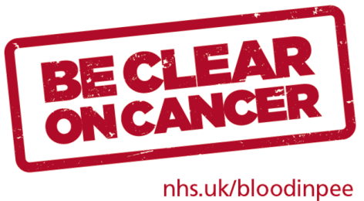
Result!
A simple be effective promotion they could all deliver easily. And did!

Hit: over 300 organisations and an estimated 17,000 people.

Northern Clinical Networks and Senate

Case study: Blood in Pee –
washroom campaign

At a glance activity:

- Make contact – with local organisations – through your website, social media, established healthy workplace teams – and don't forget your local public services, local authorities, fire service, police and ambulance crews!

- Be up front about what you can provide – if you're clear what you can offer, organisations won't expect more (some big organisations will ask for presentations or specialists/clinicians to speak to staff, if you can't do that, just say so)

- Provide the materials – do it for them if you can. Send hard copy or provide 'pick up points' at least.

- Offer support – if you can, engage local health improvement teams to support presentations to large workforces.

- Set up bespoke events – if you can – invite key health improvement leads and their teams to a presentation and provide literature to pick up and take away.

- Save the list of contacts! – tell those engaged you want to keep in touch for future public health campaigns and build the relationship.

- Keep in touch – thank those taking part and tell them about your next campaign (some plan in advance what health promotion they will do), tell them how successful the campaign was, thanks to their support. Perhaps set up regular (quarterly) e-bulletin so you can feed back national evaluation as well as local campaign news.

