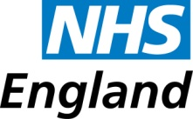

Northern Clinical Networks and Senate

Case study: Blood in Pee –
Pharmacy engagement
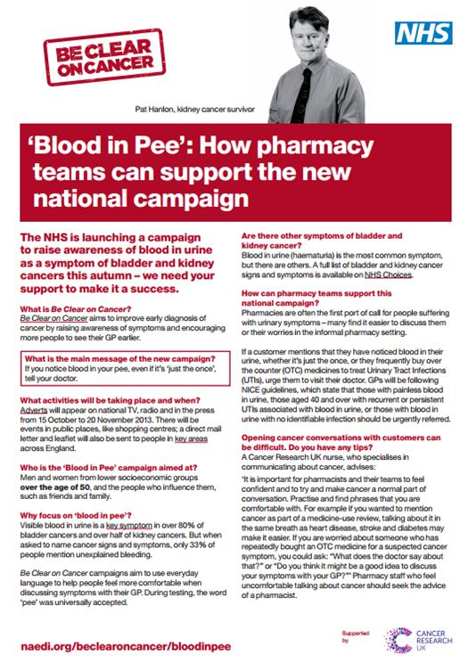
– free sample bottles to help promotion of a non-traditional public health pharmacy campaign

Background

Since the first BCOC campaigns the NECN had always included community pharmacy as a key partner in promoting awareness – not least as a primary (sometimes only) first points of contact for many of the target audience –we had a challenge with the blood in pee campaign.

Previously, most of the 660 community pharmacies across the region had supported Be Clear on Cancer very well – in particular embracing the oesophago-gastric and lung cancer campaigns as symptomatic people often made their local chemist the first port of call to buy indigestion or cough medicines. This gave pharmacist the opportunity to engage with customers directly about their symptoms and prompt them to see a GP or at least highlight the campaign.

Giving 'permission'. An important aspect of involving community pharmacy is to give reluctant patients ‘permission’ to see a doctor.

Barriers to people making an appointment can be that they think their symptoms are not serious or that they are worried about wasting their doctor's time. They effectively need an excuse or permission to make an appointment and prompting from a pharmacist can give them that.

For the bladder and kidney cancers campaign it was different

It was presumed that with a symptom as serious as blood in pee it was unlikely people would discuss this with a pharmacist first or be buying any obvious over-the-counter medicines that would indicate symptoms. In addition to the challenge, this campaign was not chosen as one of the six, annual public health campaigns to be promoted by community pharmacists locally. However, the network did not want to lose the well-established and successful relationship it had with that primary care partner.

Solution
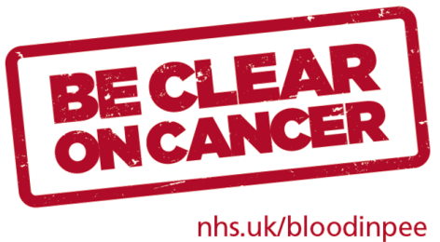
Looking for an opportunity to involve pharmacies while making it worth their efforts to promote the campaign we decided to provide a supply of sample bottles. We knew from practice managers and GPs that, while provided at surgeries, people were unlikely to visit the practice to pick up a sample bottle before making an appointment.

We also provided small, A6 sized symptom cards as these were easier and more discretely handed to customers with a sample bottle. But pharmacies were given a supply of leaflets and posters in their resource pack.

By giving a supply of sample bottles to pharmacists we could incentivise pharmacists to take part in the campaign as it would give them an opportunity to:
- display campaign materials
- ask any customers who obviously fit the target audience brief if they had seen the campaign or had a letter about it
- use the conversation to suggest symptomatic people take a sample bottle and make an appointment to see their GP

In the pack
- An introductory letter describing what we'd like them to do
- The record sheet including free-post return address
- Literature, including symptom cards
- 100 sample bottles
- The Be Clear on Cancer pharmacy briefing sheet
- A re-order form – for literature

We wanted to record the response, and while not scientific, we invited community pharmacies to complete a short, record sheet with some basic information on it. We asked pharmacies to at a minimum record their postcode if they took part, along with some additional information if they could supply it. Not all pharmacies were able to complete the whole record sheet and not all patient information was noted but it gave us a feel for how successful the idea was.
“Our local community pharmacists play a vital role in supporting early diagnosis of cancer and have supported the Be Clear on Cancer campaigns extremely positively.
The blood in pee campaign gave them an extraordinary opportunity to talk to customers about a symptom people may not normally approach their pharmacist with".
Suzanne Thompson; Awareness and Early Diagnosis lead, NSCN
The form asked:
- Postcode of pharmacy
- Gender of customer
- If the customer approached the pharmacist or if the pharmacist engaged them
- It they sited any other symptoms
- Did they take a sample bottle
- Did they take a symptom card

Key to the success
Was our strong and supportive relationship with the local pharmaceutical committee which, not only endorsed the campaign and the sample bottle campaign but also guided tested and advised on the content of the record sheet.

Result!

A fifth (132) of all the region's community pharmacies responded and between them engaged with 289 customers in total.

Of the information recorded from the engaged customers:
- 121 were female
- 85 were male
- 181 sited no symptoms per say but 27 did have symptoms and – six of those included blood in their urine.
- 134 (46%) of the customers made the first approach for help
- 82 pharmacists engage the customer first
- 148 customers took a sample bottle
- 142 took a symptom card or leaflet

