EPWDA 11

Supplementary materials
- Risk assessment – primary school
- Risk assessment – secondary school
- Invitation – Cook and Eat Family Fun
- Invitation – Cook and Eat Fun!
- Quiz – Cook and Eat Fun (secondary)
- Lesson plans – Cook and Eat Fun (secondary) – 2 lesson plans (savoury/sweet)
- Lesson plans – Cook and Eat Family Fun (primary) – 1 lesson plan
- Recipes –vegetable pizza, cottage pie, chocolate brownie, rocket fruit
- Worksheets – rocket fruit (primary) and chocolate brownies (secondary)

Anna and Maria (St Peters School) | Maria and Justine (Exmouth School)
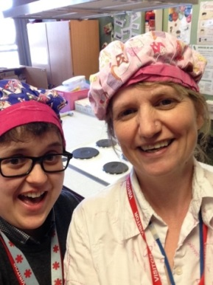 | 