Electronic Glucose Monitoring Chart of University Hospital Birmingham NHS Foundation Trust

Examples of the electronic blood glucose monitoring system before and after the lab glucose and ABG glucose measurements were included are below.

Figure 1: Pre-intervention monitoring screen

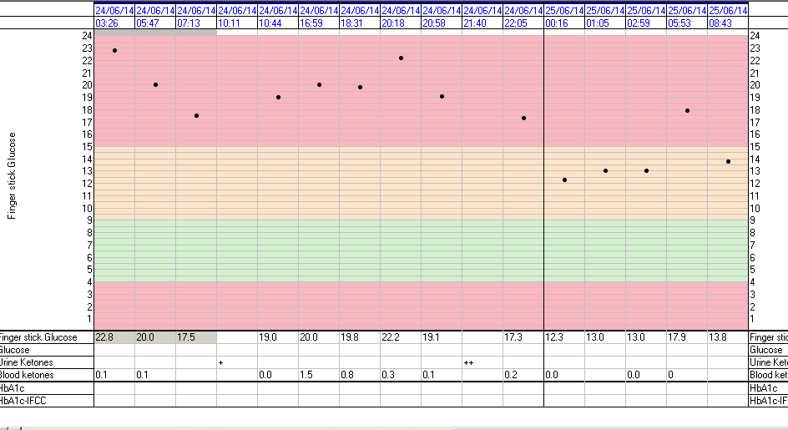

Figure 2: Post-intervention based on user feedback changes made to glucose monitoring screen:

